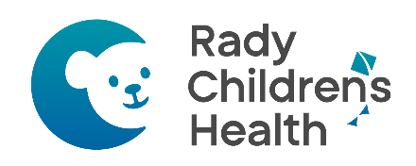
At Rady Children’s Health at Mission, every improvement we make is guided by one promise — to keep children safe while providing the most advanced care possible. Sometimes, new technology or care spaces don’t fit perfectly within older state regulations. In those cases, Rady works closely with the California Department of Public Health (CDPH) to request a Program Flexibility Waiver.

These waivers allow us to use modern, evidence-based approaches that meet — or exceed — all safety standards. Each request is thoroughly reviewed and approved by CDPH before implementing.

California Department of Public Health (CDPH) Program Flexibilities
FLEX # | Title 22 Regulation | Title | Start Date | Expiration Date
12893 | §70217(a)(1)  §70485(d) | NICU 1:3 Staffing | 11/15/2025 | 11/14/2026
7692 | §70551(d)(10) | Erythromycin Eye Prophylaxis | 12/28/2023 | 12/27/2026
7818 | §70833(c)(3) | Event Related Sterility | 01/22/2024 | 01/21/2027
13096 | §70805 | Pediatric Patients Overflow in NICU (PedsNIC) | 12/18/2025 | 12/17/2028
13116 | §70307(b) | Program Flex Condensed List Posting | 01/26/2026 | 01/01/2029
13000 | §70805 | PICU Patients Overflow in NICU (PICNIC) | 01/17/2026 | 01/16/2029
15052 | §70723(b)(3)  §70723(b)(4) | TB Screening | 08/05/2026 | 08/05/2029

To view the full approval letters, scan the QR code below or request to review the program flexes in the Administration Office during regular business hours. After hours, contact the house supervisor to review the program flexes.

Updated 8/5/2026

