Converting a scheduled appointment to Telehealth
- Reschedule the appointment
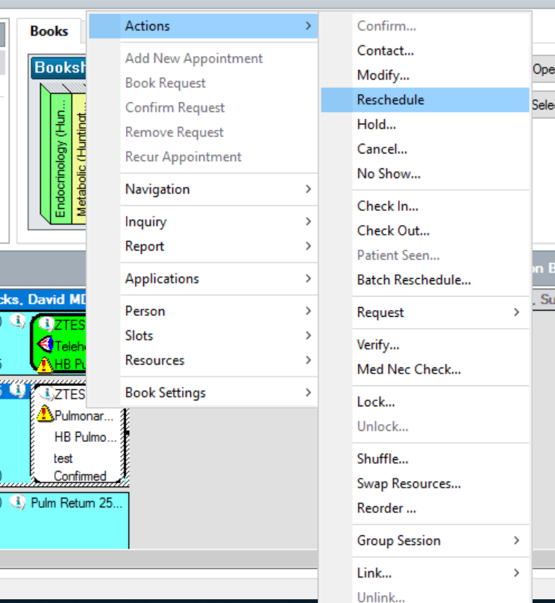
- Click “No” when prompted to retain encounter association
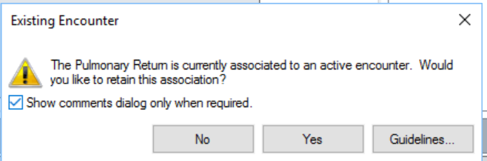

- Click the Next button, which allows to change the appointment type:
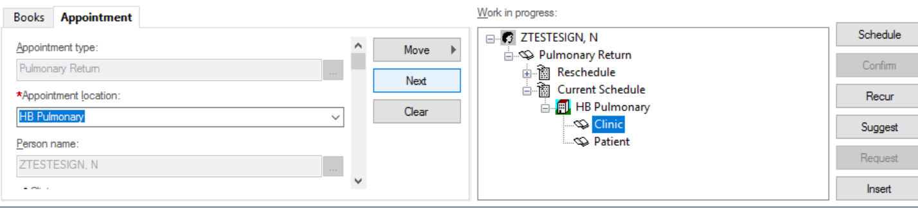

Change the appointment type to Telehealth (Specialty) or (Primary)
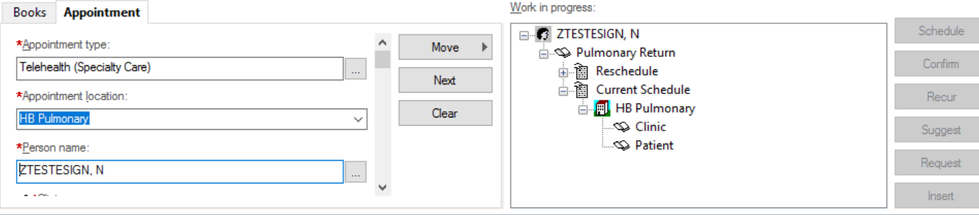

- Click the Move button to move the changes to the Work in Progress window
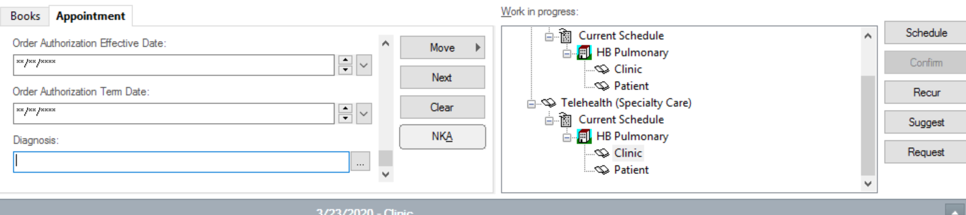

- Select the same time slot and click on schedule button, click on override
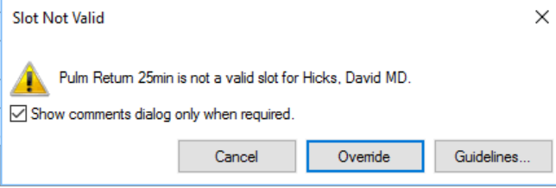

- Choose reason Alternate Appointment Scheduled and click OK.
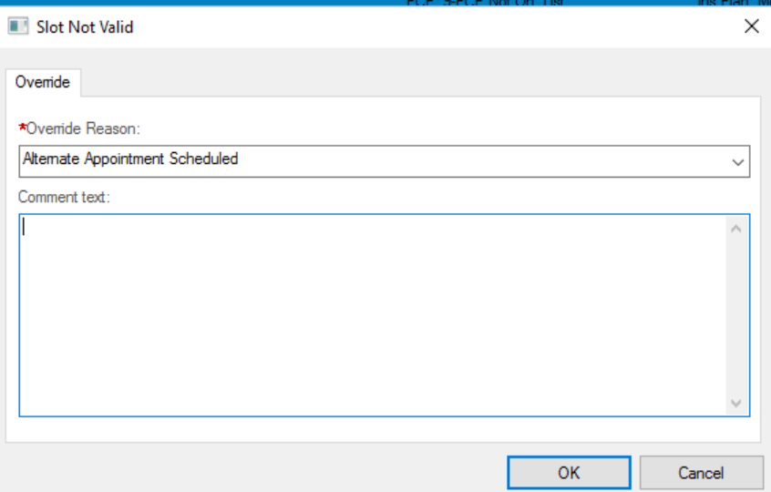

- Add an Encounter, choose PreReg OP Telehealth. Complete the rest of the required fields.
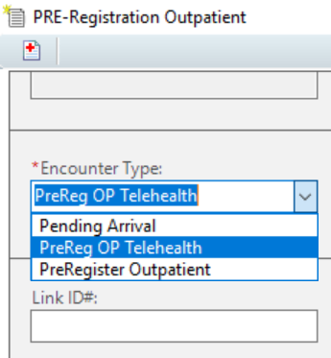

- During Check in, make sure to flip the encounter to Outpatient Telehealth
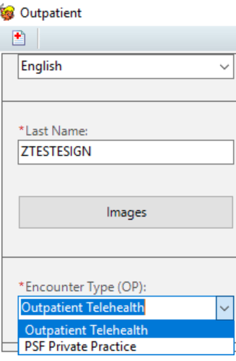
- Make sure to cancel the non telehealth appointment to avoid confusion:
